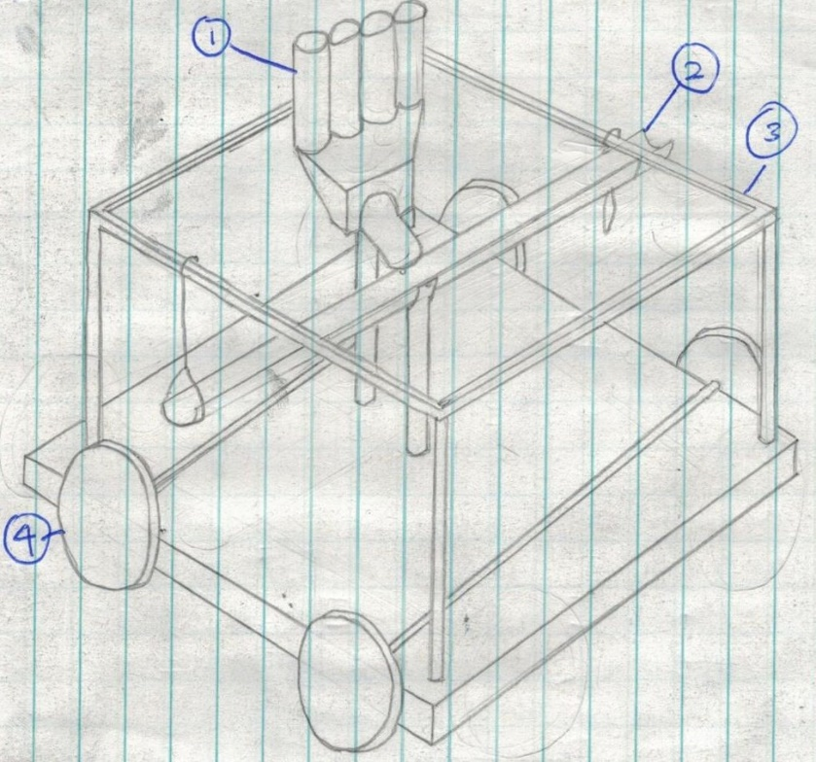

1.This design uses a swinging pipe to distribute balls on either side of the device. It contains balls in 4 elevated tubes, which have electronic gates on them to release balls when required. The containers can rotate and deposit balls into either side of the pipe, utilising gravity to tip the pipe so balls can roll down. The pipe is attached to the thin metal frame by string at each end, which prevents the pipe from tipping too far.

The inspiration in this design is the idea that gravity is the fastest way to deposit balls, and that the device would not have to turn around if the device could deposit balls on either side, saving time. Depositing balls into the pipe would make the device easier to construct, and if the device had to turn 180 degrees at the end, it would have to take a large turning circle, wasting time.

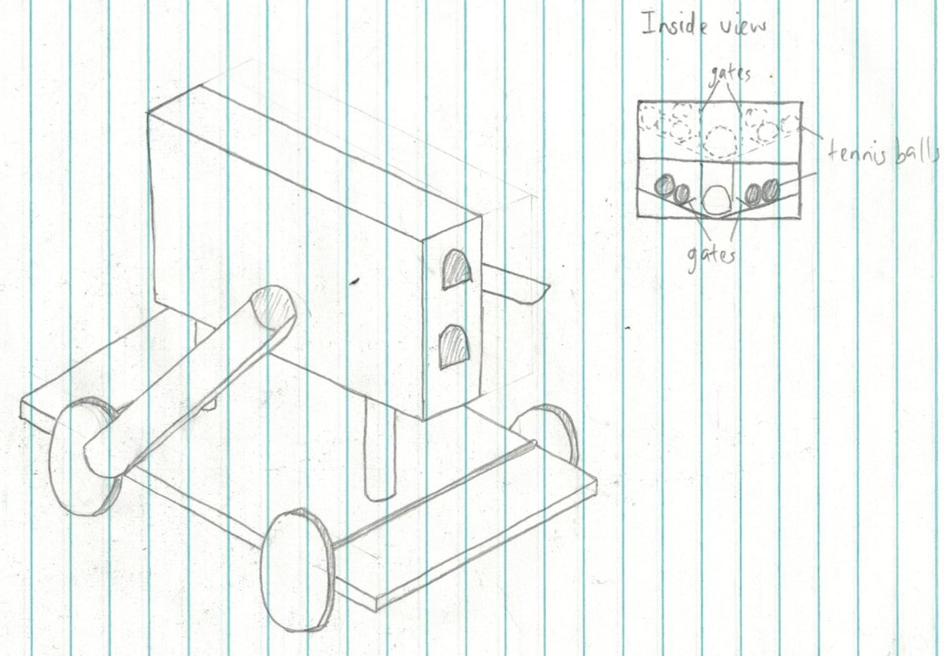

2.This design uses 2 pipes to deposit balls on either side of the device, and balls are fed into these pipes via a large central storage unit. The storage container is split into 4 compartments where balls are stored: 2 in the top section, and 2 in the bottom section. In each compartment, balls are held by electronic gates which can release balls into one of the two pipes, and the right one is placed higher since the ball receptacles are higher on the right side.

The inspiration for this design is the previous pipe-based design. This design is an improvement of the original design, improving aspects such as accuracy with the fixed height pipes, and improving the ease of assembly by reducing the number of moving parts.